Practical - 3
Practical Title: Responsive UI Design using CSS Grid, Flexbox, and Bootstrap/Tailwind

Problem Definition: Design responsive layouts for Home, About, Registration, Dashboard, and Events pages using CSS Grid and Flexbox. Optional to use CSS framework such as Bootstrap or Tailwind. Ensure mobile-first responsiveness.

Theory

How does the layout adapt for mobile, tablet, and desktop screens?
Answer: The layout adapts to different screen sizes using responsive web design. CSS media queries can be used to apply different styles at different screen widths. On smaller screens such as mobile phones, the content can be arranged vertically, while on tablets and desktops it can use wider layouts with multiple columns. This makes the website usable on mobile, tablet, and desktop devices.

Reference Link:
https://www.w3schools.com/Css/css_rwd_mediaqueries.asp

Which layout technique is used and why?
Answer: The CSS Flexbox layout technique is used because it provides a flexible and responsive way to arrange elements in rows or columns. It makes it easier to align items, distribute space, and adapt the layout to different screen sizes. Flexbox is suitable for Student Hub components such as navigation menus, cards, forms, and content sections.

Reference Link:
https://www.w3schools.com/css/css3_flexbox.asp

3. Are typography, spacing, colors, and contrast readable?
Answer: Yes. Readable fonts, suitable font sizes, proper spacing, and sufficient contrast between text and background are used to improve readability. Good color contrast is especially important for users with visual difficulties. Proper font size and line height also make the content easier to read.

Reference Link:
https://www.w3schools.com/css/css_accessibility.asp

4. Is the framework used consistently without unnecessary inline CSS?
Answer: Yes. The website uses a consistent CSS approach by keeping common styling in an external CSS file rather than repeatedly using inline CSS. An external stylesheet allows the same styles to be applied to multiple HTML pages, making the website easier to maintain and keeping the code organized. Inline CSS is avoided unless a specific individual style is required

Reference Link:
https://www.w3schools.com/css/css_external.asp

Implementation/ Output/Result
- /* Reset */
- *{
- margin:0;
- padding:0;
- box-sizing:border-box;
- }

- /* Body */
- body{
- font-family:Arial, Helvetica, sans-serif;
- background-color:#f4f7fc;
- color:#333;
- }

- /* Main Heading */
- h1{
- background-color:#0b5ed7;
- color:white;
- padding:20px;
- text-align:center;
- }

- /* Search Box */
- input[type="text"]{
- width:250px;
- padding:8px;
- margin:20px;
- border: 2px solid blue;
- border-radius:5px;
- }

- input[type="password"]{
- width:250px;
- padding:8px;
- margin:20px;
- border: 2px solid blue;
- border-radius:5px;
- }

- input[type="email"]{
- width:250px;
- padding:8px;
- margin:20px;
- border: 2px solid blue;
- border-radius:5px;
- }

- input[type="tel"]{
- width:250px;
- padding:8px;
- margin:20px;
- border: 2px solid blue;
- border-radius:5px;
- }

- input[type="submit"]{
- width:250px;
- padding:8px;
- margin:20px;
- border-radius:5px;
- background-color: #0b4b90;
- color: white;
- }
- /* Login and Sign Up Links */
- a{
- text-decoration:none;
- color:#0b5ed7;
- font-size:18px;
- margin-right:15px;
- }

- a:hover{
- color:red;
- }

- /* Horizontal Line */
- hr{
- margin:20px 0;
- }

- /* Menu Heading */
- h3{
- font-size:35px;
- margin-left:20px;
- margin-bottom:10px;
- color:#0b5ed7;
- }

- /* List */
- ul{
- margin-left:40px;
- margin-bottom:25px;
- }

- li{
- margin-bottom:10px;
- }

- /* Welcome Heading */
- h2{
- margin-left:20px;
- color:#0b5ed7;
- }

- /* Paragraph */
- p{
- margin:20px;
- font-size:18px;
- line-height:1.6;
- }

- table{
- width: 700px;
- margin: 40px auto;
- border-collapse: collapse;
- background-color: white;
- border-radius: 10px;
- overflow: hidden;
- box-shadow: 0 4px 12px rgba(0,0,0,0.2);

- }

- th{
- color: black;
- padding: 15px;
- font-size: 20px;
- text-align: center;
- }

- td{
- padding: 15px;
- font-size: 18px;
- text-align: center;
- border: 1px solid #ddd;
- }

- td{
- padding: 15px;
- font-size: 18px;
- text-align: center;
- border: 1px solid #ddd;
- }

- tr:hover{
- background-color: #e3f2fd;
- }

- th:first-child{
- border-top-left-radius: 10px;
- }

- th:last-child{
- border-top-right-radius: 10px;
- }

- label{
- display:block;
- margin-top:15px;
- font-size:18px;
- font-weight:bold;

- }

- input{
- width:100%;
- padding:10px;
- margin-top:5px;
- margin-bottom:15px;
- border:2px solid blue;
- border-radius:5px;
- box-sizing:border-box;
- }

- fieldset{
- width:400px;
- margin:40px auto;
- padding:30px;
- border:2px solid #0b4b90;
- border-radius:10px;
- background-color:white;
- box-shadow:0px 4px 10px gray;
- text-align:center;
- }

Evidence of Work (Screenshots)
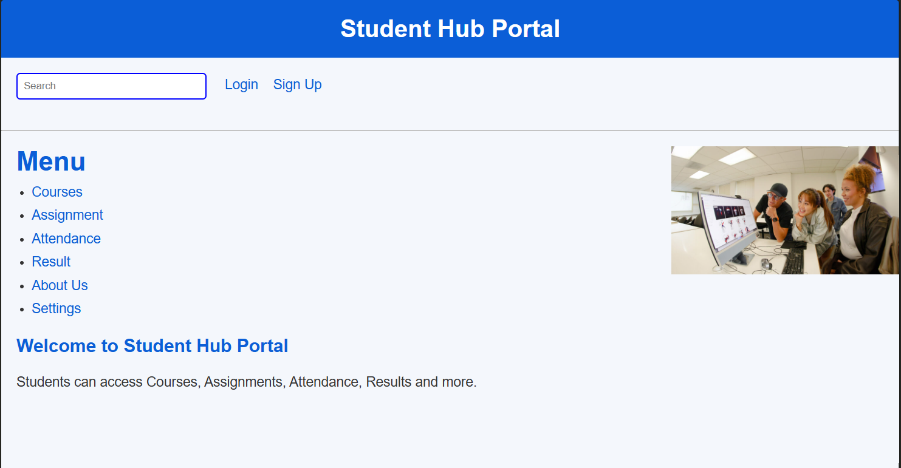
Description: This figure shows the Home Page of the Student Hub Portal. It contains a header with the Student Hub Portal title, a search box, and Login and Sign Up links for user access. The page includes a Menu section with navigation links to Courses, Assignment, Attendance, Result, About Us, and Settings. An image is displayed on the right side, while the welcome section provides a brief introduction to the portal and explains that students can access courses, assignments, attendance, results, and other resources

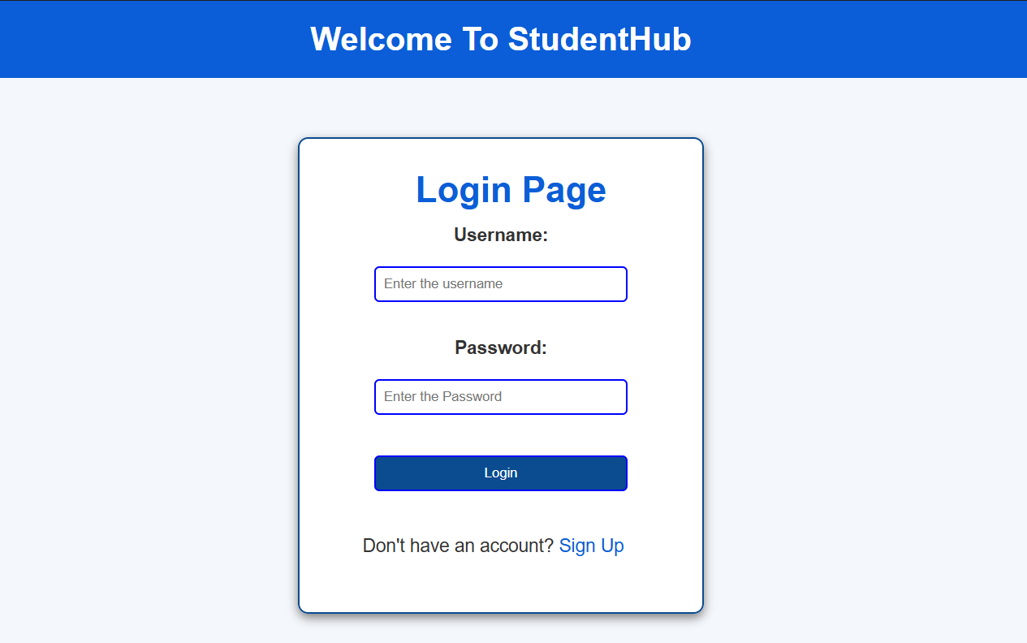
Description: This figure shows the Login Page of the StudentHub Portal. It contains a welcome heading at the top, followed by a login form with fields for Username and Password. A Login button is provided to submit the credentials. For new users, a Sign Up link is available to create an account. The page uses a simple and clean layout with blue headings, bordered input fields, and a centered login box for easy navigation and user interaction
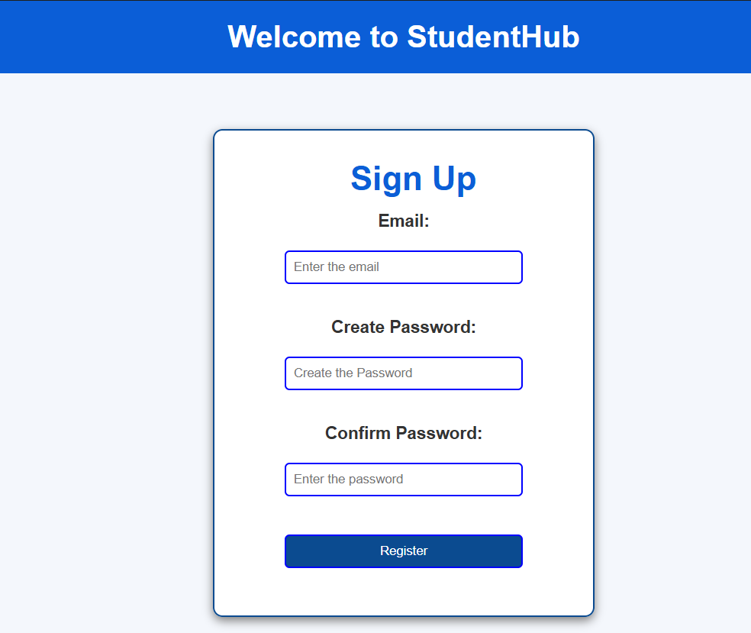
Description: This figure shows the registration page of StudentHub. Students can enter their email, create a password, and confirm the password. A Register button is provided to create a new account.

Description: This figure displays the Courses section of the portal. It lists the available courses, including Web Development Framework, Programming with C++, and Data Structure and Algorithm. Students can select these courses to access their academic information.
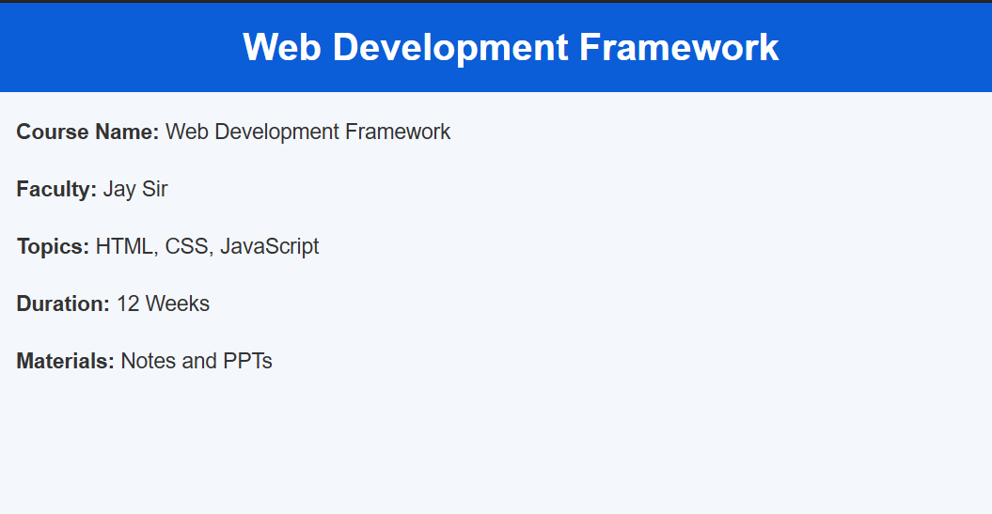
Description: This figure provides detailed information about the Web Development Framework course. It shows the course name, faculty, topics such as HTML, CSS, and JavaScript, course duration of 12 weeks, and the available learning materials such as notes and PPTs.
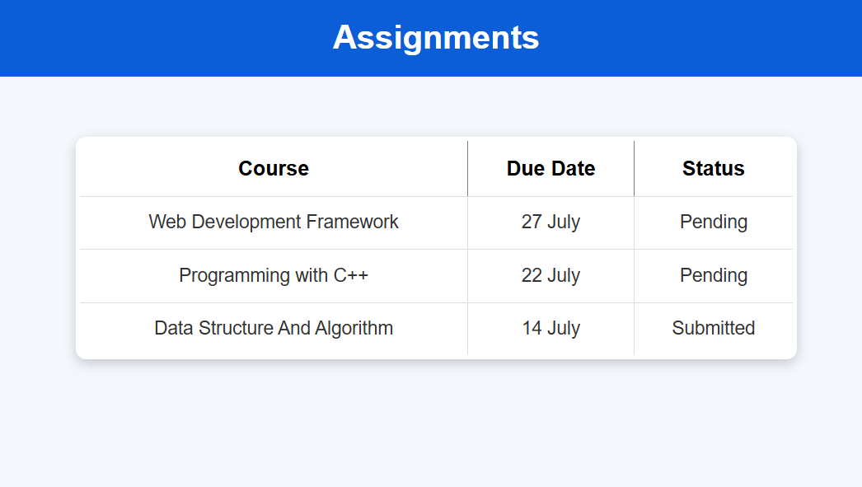
Description: This figure shows the Assignments section of StudentHub. Assignments are displayed in a table containing the course name, due date, and submission status. The status indicates whether an assignment is Pending or Submitted.
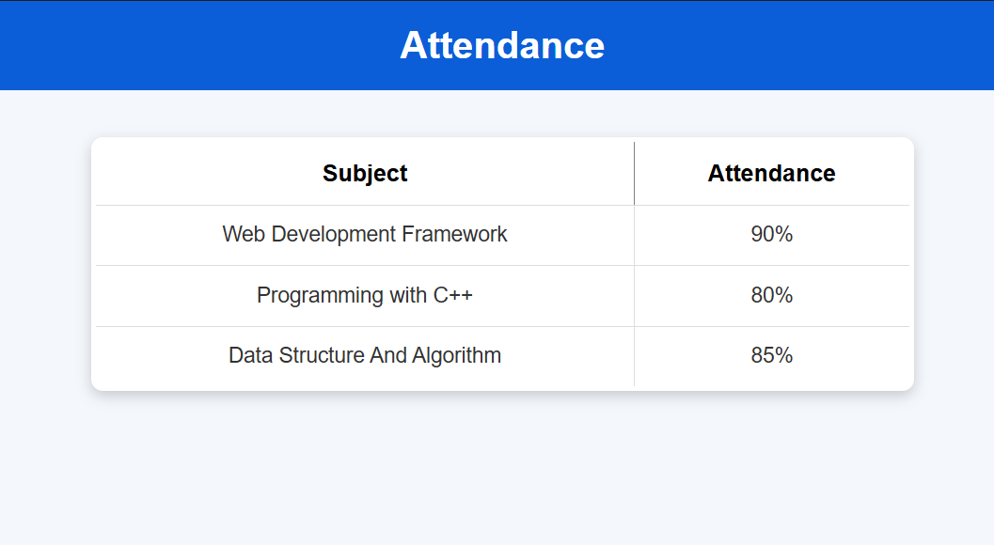
Description: This figure displays the student's attendance information for different subjects. The table shows the subject names along with their attendance percentages, allowing students to monitor their attendance.
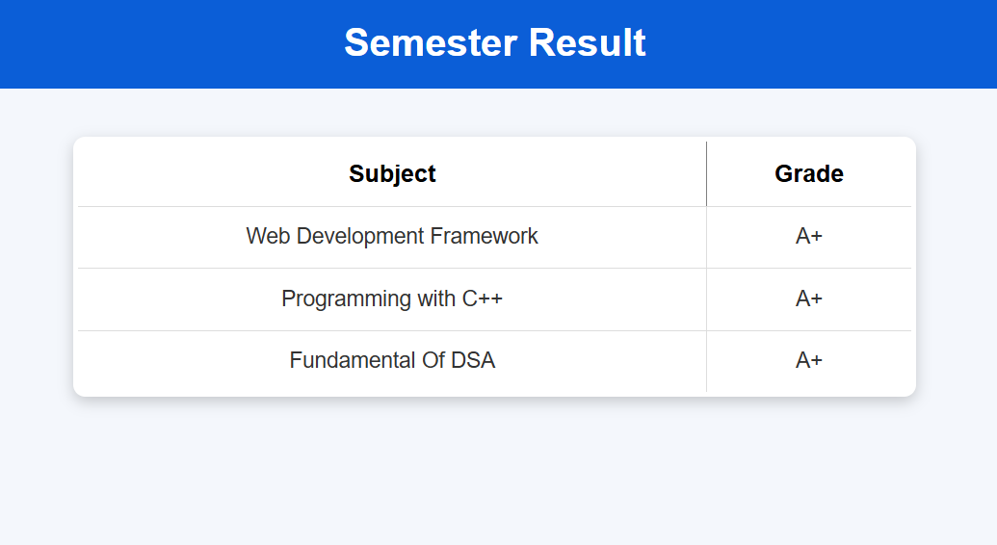
Description: This figure shows the Semester Result section. It displays the subjects along with the grades obtained by the student, providing a simple way to view academic performance.
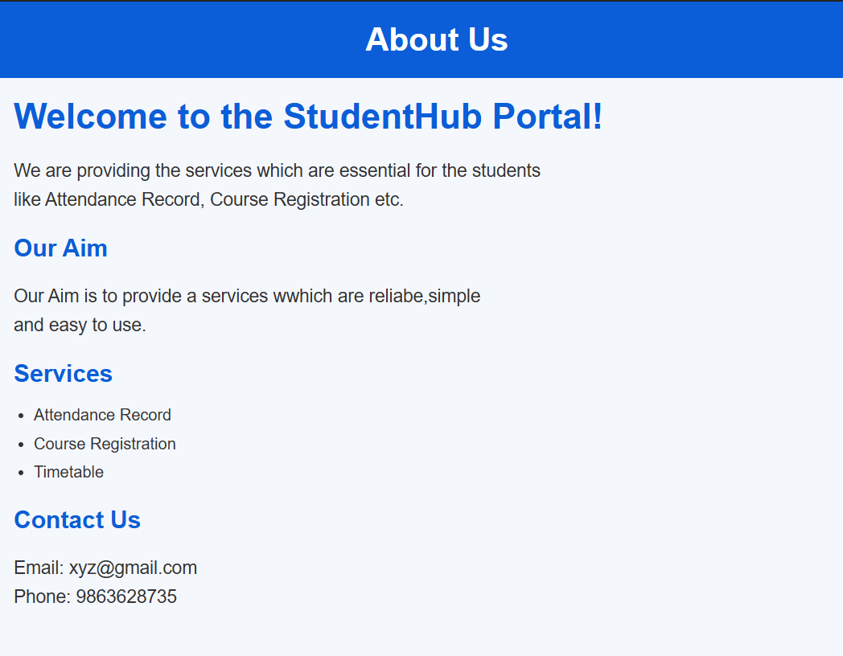
Description: This figure presents the About Us section of the StudentHub Portal. It explains the purpose of the portal, its aim, the services provided to students, and contact information. The services include attendance records, course registration, and timetable.
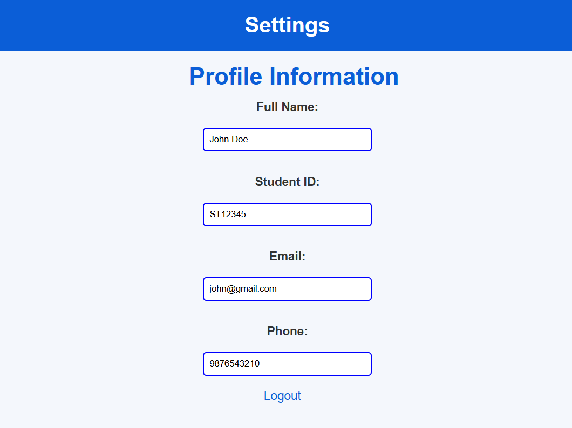
Description: This figure shows the Settings page containing the student's profile information. It includes fields for Full Name, Student ID, Email, and Phone Number, along with a Logout option. This page allows students to view or manage their personal information.

GitHub Repository Link:
https://github.com/devanshirshah24-pixel/WDF-Practicals/tree/main/Practical3

Challenges Faced:
During the implementation of the responsive StudentHub layouts, I faced the following challenges:
- Responsive layout: It was challenging to make the pages look proper on different screen sizes. This was solved by using CSS media queries.
- Using Grid and Flexbox: Initially, it was difficult to decide when to use Grid and when to use Flexbox. Flexbox was mainly used for navigation and alignment, while Grid was used for card-based and multi-column layouts.
- Mobile-first design: Designing the layout for smaller screens first required careful planning of the content and spacing.
- Maintaining consistency: The same typography, spacing, navigation, and design patterns had to be maintained across Home, About, Registration, Dashboard, and Events pages.
- Avoiding unnecessary inline CSS: Styling was moved to an external CSS file so that the same styles could be reused across multiple pages.

Learning Outcomes:
- How to design responsive web layouts.
- How to use CSS Flexbox for flexible element alignment.
- How to use CSS Grid for row and column-based layouts.
- How to use media queries for different screen sizes.
- How to follow a mobile-first approach.
- How to maintain readable typography, spacing, colors, and contrast.
- How to use an external CSS stylesheet instead of unnecessary inline CSS.
- How to create consistent layouts across multiple StudentHub pages.
- How to test responsive designs using the browser's responsive/device mode.
- How responsive design improves the usability of a website on different devices.

Faculty Remarks: (Keep this blank for faculty)

